The Little Lantern That Would Not Go Out

A gentle children’s story about a little lantern who learns that even the smallest light can make a big difference.

Chapter One: A Small Light in a Big Village
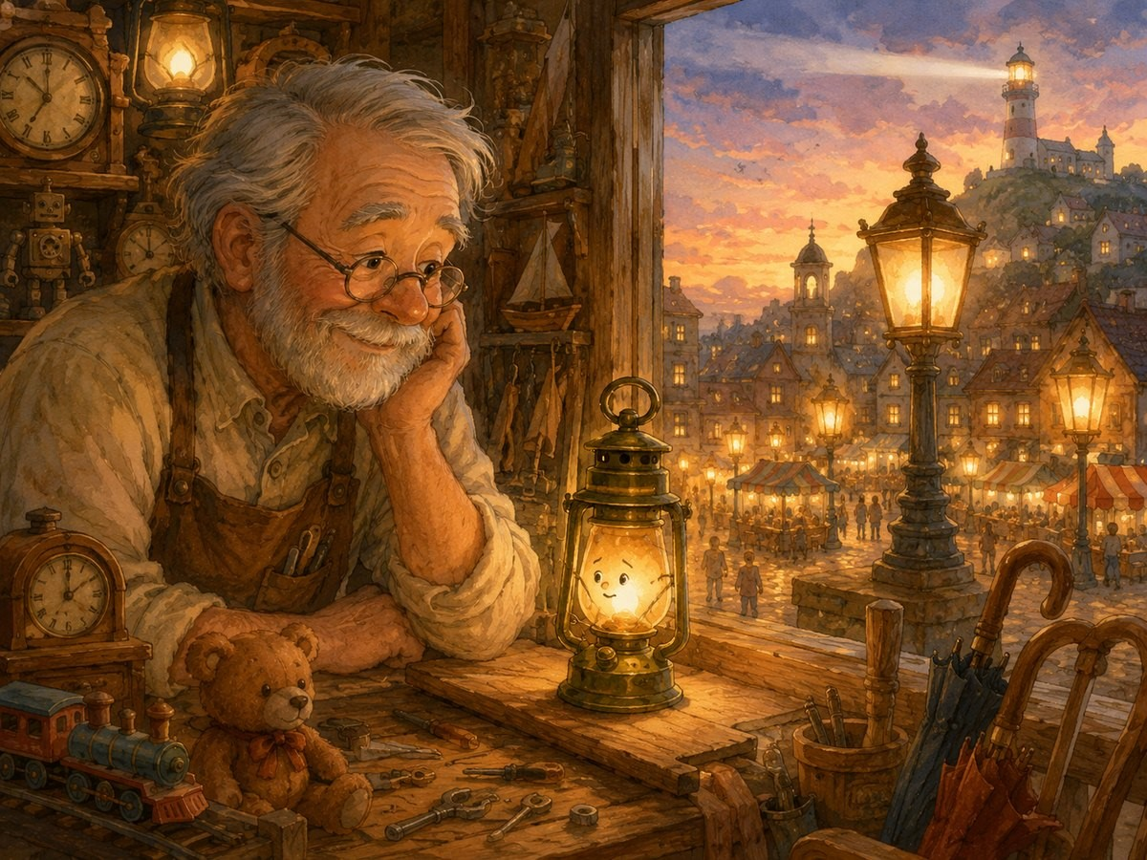
In a small village tucked between green hills and a quiet blue river, there lived a little lantern named Luma.
Luma was not the biggest lantern in the village. She was not the brightest either. She did not hang outside the grand town hall, where everyone could see her golden glow. She did not sit beside the baker’s window, warming the faces of children who came to buy sweet bread. She did not shine from the tall lighthouse on the hill, guiding travellers from far away.
Luma lived in a tiny wooden shop at the end of a narrow lane. The shop belonged to an old man named Grandpa Niko, who repaired broken things. He fixed chairs with wobbly legs, clocks that had forgotten how to tick, umbrellas with torn covers, and toys whose wheels had fallen off.
Every evening, when the sun dipped behind the hills, Grandpa Niko would light Luma and place her by the window. “There you are, little one,” he would say kindly. “A small light is still a light.” Luma loved those words.
But sometimes, when she looked out of the window and saw the bigger lanterns glowing across the village, she felt very small. The lantern outside the town hall shone like a golden crown. The lanterns near the market danced in rows, bright and proud. The lighthouse lantern on the hill sent its beam far across the river. Luma looked at her own tiny flame and sighed. “I am only a little lantern,” she whispered. “What difference can I make?”

Chapter Two: When the Storm Arrived
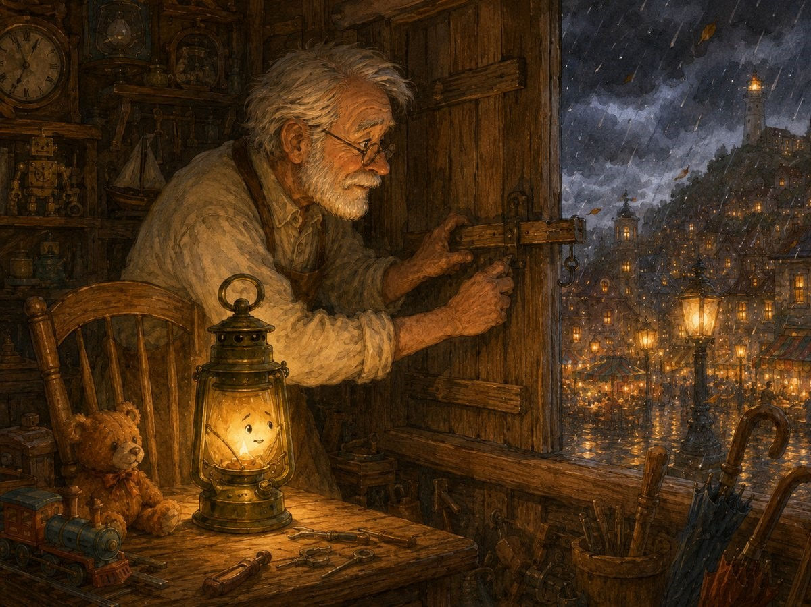
One chilly evening, dark clouds gathered above the village. The wind began to whistle through the trees, bending their branches from side to side. The birds hurried to their nests, and the market sellers packed away their baskets.
Grandpa Niko looked out of the window. “A storm is coming,” he said. He closed the shop door, checked the shutters, and placed Luma on the table beside his chair.
Outside, the sky grew darker and darker. Then came the rain. At first, it tapped softly on the roof. Tap. Tap. Tap. Then it poured harder. Drum. Drum. Drum. The wind howled down the narrow lane. It shook the signs above the shops and rattled the windows of every little house.
Luma’s flame trembled. “Oh dear,” she whispered. Grandpa Niko smiled gently. “Do not be afraid, Luma. Even a trembling light can still shine.” Luma tried her best to glow steadily. But deep inside, she was worried. What if the wind found a way through the shutters? What if her little flame went out? What if she was not strong enough?

Chapter Three: The Last Light Still Burning
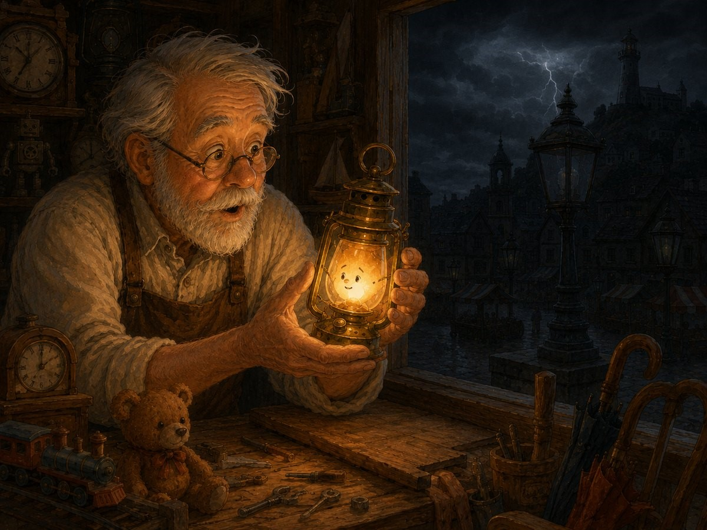
Across the village, families gathered indoors. Parents tucked blankets around their children. Dogs curled up near fireplaces. Cats hid beneath chairs. The baker covered his ovens. The farmer checked his barn. The schoolteacher shut the classroom windows tightly.
Then, suddenly—CRACK! A great flash of lightning tore across the sky. A moment later, thunder boomed so loudly that every window in the village shook. Luma jumped.
Grandpa Niko stood up slowly and looked outside. The village had gone dark. One by one, the great lanterns had gone out. The town hall lantern was dark. The market lanterns were dark. Even the lighthouse on the hill had disappeared into the stormy night.
Luma looked around. Her small flame was still burning. She could hardly believe it. “I am still lit,” she whispered. Grandpa Niko picked her up carefully. “Yes,” he said.
“And tonight, that may matter more than you know.”

Chapter Four: Mira at the Door
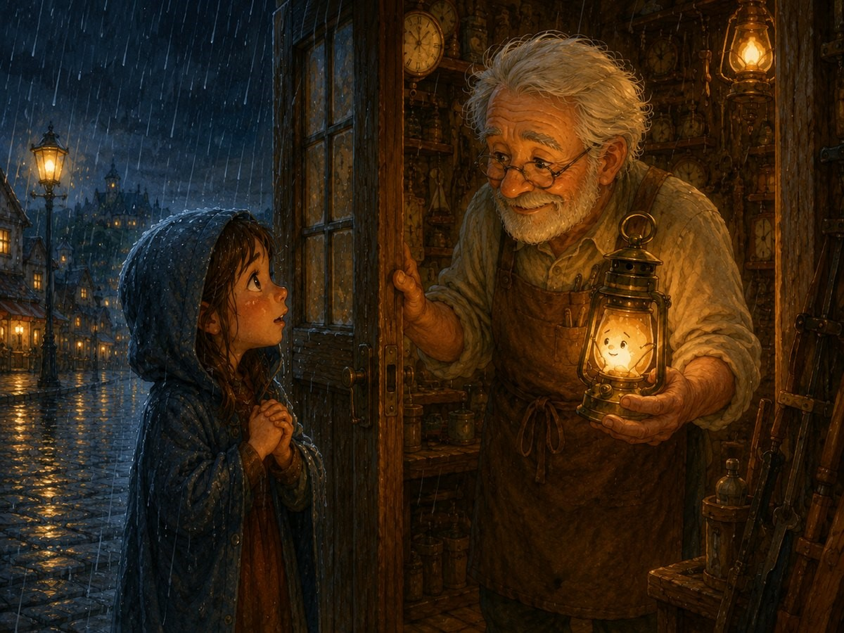
Just then, there was a knock at the door. Knock, knock, knock. Grandpa Niko opened it.
A young girl stood outside, soaked from the rain. Her name was Mira. She lived near the river with her mother and baby brother.
“Grandpa Niko!” Mira cried. “The bridge path is flooded, and my mother cannot find the way to the village shelter. We saw your light from the lane. Please, can you help us?”
Luma’s flame flickered with surprise. Someone had seen her? Her little light? Grandpa Niko wrapped his coat around his shoulders and held Luma high. “Lead the way, Mira,” he said.

Chapter Five: Follow the Light
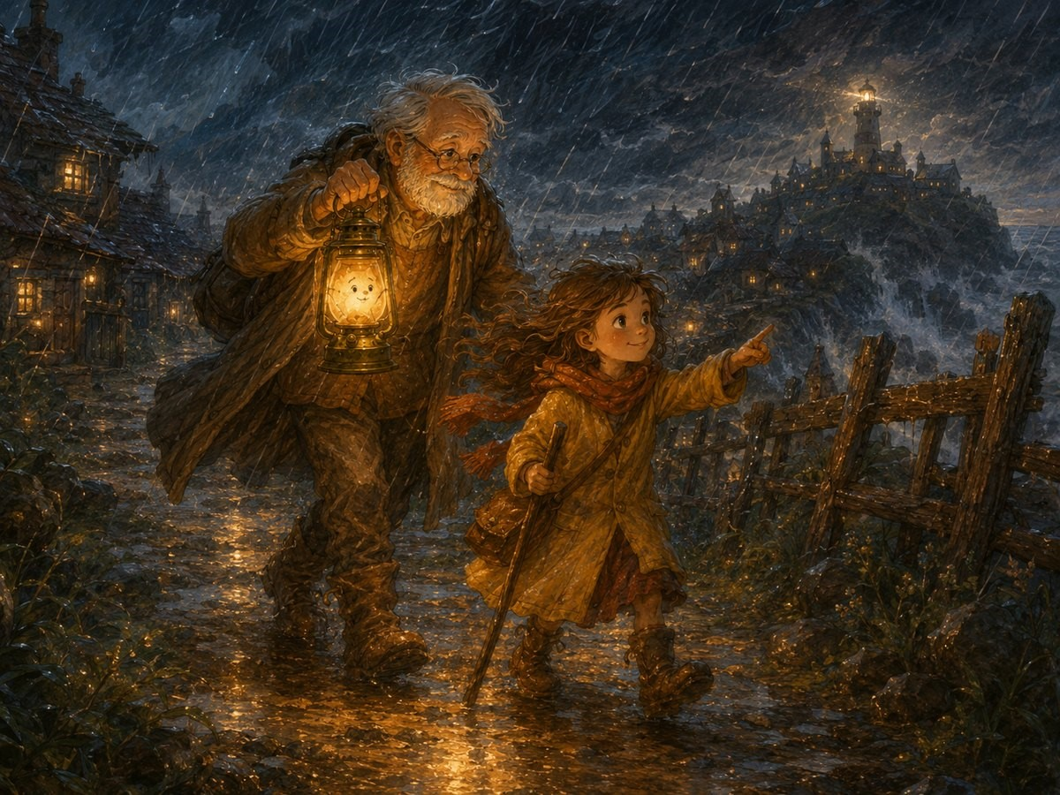
The wind pushed against them as they stepped into the storm. Luma had never been outside in weather like this before. Rain splashed against her glass. The wind tried to blow around her metal frame. The road beneath them was muddy and slippery.
But Grandpa Niko held her close. “Shine, little one,” he said. So Luma shone. She shone on the puddles so Mira could step around them. She shone on the stones so Grandpa Niko would not trip. She shone on the narrow lane, the crooked fence, and the muddy path that led toward the river.
At last, they found Mira’s mother standing beneath a large tree, holding the baby tightly in her arms. “Oh, thank goodness!” Mira’s mother cried. “We could not see the path.” Luma glowed brighter. “This way,” said Grandpa Niko. “Follow the light.” Slowly and carefully, they made their way back toward the village.
Luma was tired. Her flame felt small against the giant storm. But every time she wondered if she could keep going, she heard Mira whisper, “I can see. I can see the path.” And Luma kept shining.

Chapter Six: Light in the Shelter
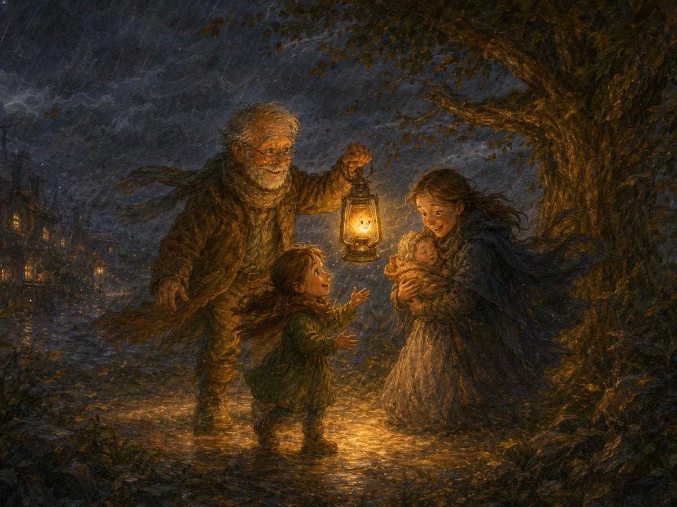
When they reached the village shelter, more people were waiting in the dark. The shelter was the strongest building in the village, with thick stone walls and a wide wooden door. But without the village lanterns, families were frightened. Children clung to their parents. The old baker sat quietly in the corner. The schoolteacher tried to comfort the little ones, but even she looked worried.
Then Grandpa Niko stepped inside, holding Luma high. A soft golden glow filled the room. Everyone turned. “The repair shop lantern!” someone said. “It is still burning!”
The children gathered closer. One little boy pointed at Luma and smiled. “She looks like a tiny star.” Luma felt warmth spread through her frame. A tiny star. She liked that.
Grandpa Niko placed her in the centre of the shelter. Her light did not fill every corner, but it was enough for people to see each other’s faces. And once they could see each other, they felt less afraid. The baker shared bread from his basket. The farmer told a funny story about a goat who once ate his hat. The schoolteacher led the children in a quiet song. Mira rocked her baby brother, and he stopped crying. All the while, Luma kept shining.
Hours passed. The storm grew stronger, then softer, then stronger again. Luma’s flame dipped low. “Oh no,” she whispered. “I am getting tired.” Grandpa Niko noticed. He bent close to her and gently adjusted her wick. “You have done well,” he said. “But I am so small,” Luma said, though only Grandpa Niko seemed to understand lantern talk. Grandpa Niko smiled. “Small things can do brave things.”

Chapter Seven: A New Mission
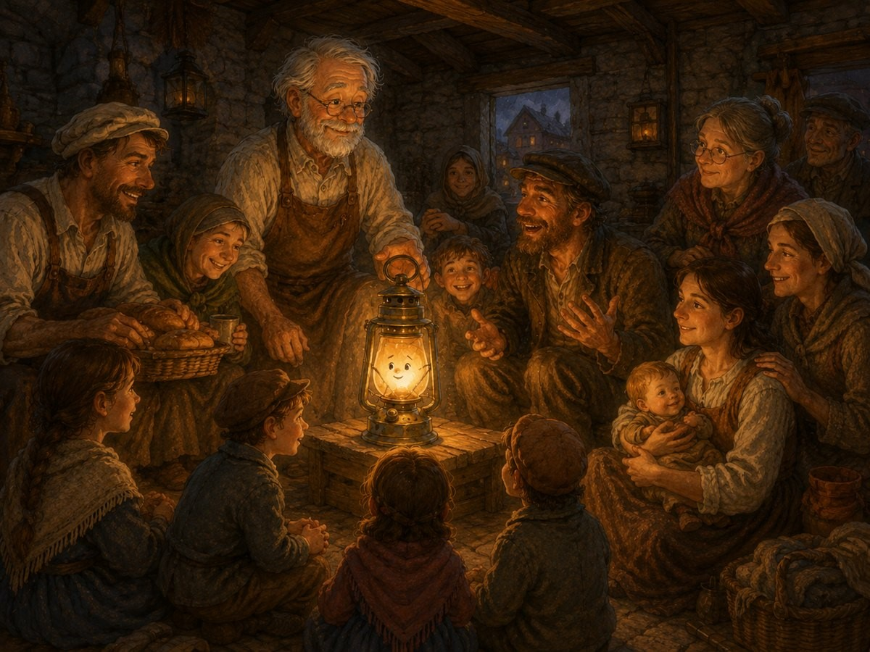
Luma looked around the shelter. She saw Mira safe with her mother. She saw the children smiling. She saw neighbours helping one another. She saw people who had been scared now sitting together in peace. Maybe she was small. But maybe small did not mean useless. Maybe small did not mean weak. Maybe small simply meant there was still room to grow.
Near midnight, there came another knock at the shelter door. This time, it was the village guard. “The road to the hill is blocked,” he said. “The lighthouse keeper is injured, and the lighthouse lantern is out. If boats are on the river, they will not see the bend.”
Everyone grew quiet. The river bend was dangerous during storms. Boats needed the lighthouse to guide them away from the rocks. The village guard looked at Grandpa Niko. “Your lantern is the only one still burning,” he said.
Luma froze. The only one? Grandpa Niko lifted her gently. “It is a long walk to the hill,” he said. “But we can try.” For a moment, Luma wanted to hide beneath the table. Then she heard Mira’s voice. “You can do it, little star.” The children nodded. “You helped us,” said the little boy. “You are brave,” said another child. Luma’s flame stood a little taller. Grandpa Niko carried her into the storm once more.

Chapter Eight: The Climb to the Lighthouse
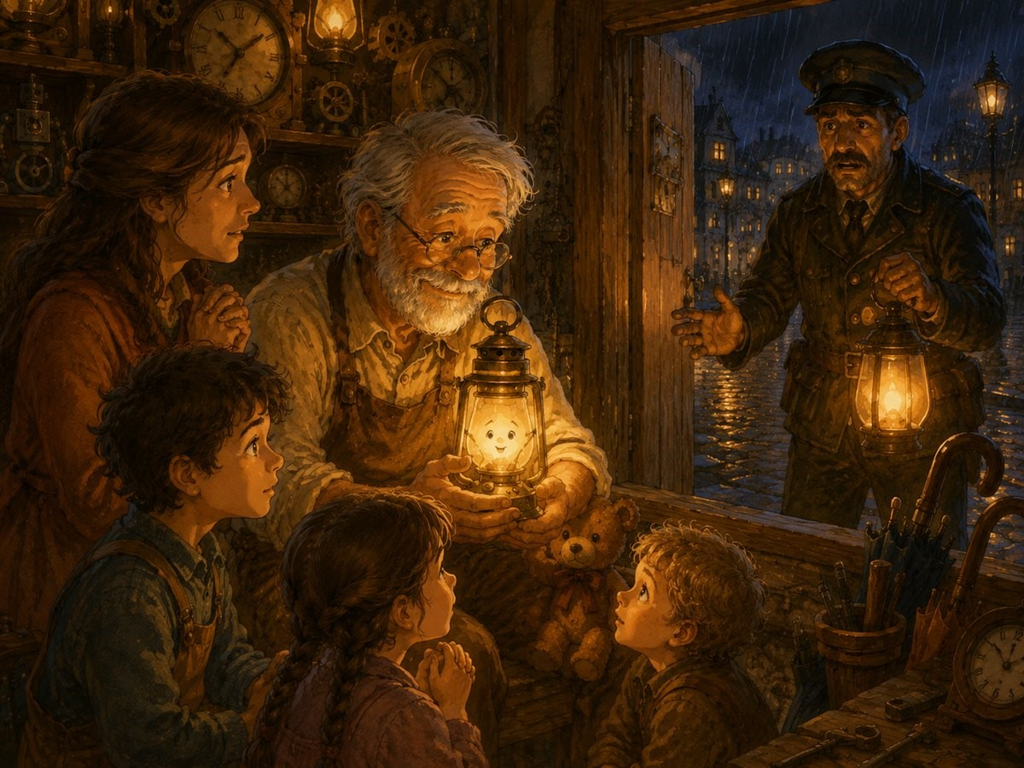
The climb to the lighthouse was steep and slippery. The path twisted between rocks and bushes. Rain ran down the hill like tiny rivers. Grandpa Niko moved slowly. The village guard walked beside him. Luma shone as brightly as she could.
Step by step, they climbed. Sometimes the wind pushed so hard that Grandpa Niko had to stop and turn his back to protect Luma’s flame. Sometimes the rain covered Luma’s glass, making everything blurry. But still, she shone.
At last, they reached the lighthouse. Inside, the lighthouse keeper sat on a chair, holding his bandaged arm. “The great lantern will not light,” he said sadly. “The storm damaged the mechanism.” Grandpa Niko looked at Luma. Then he looked at the great lighthouse lamp. “We may not be able to fix it tonight,” he said, “but we can place Luma near the top window.”
Luma could hardly speak. “Me?” she whispered. “Yes, little one,” said Grandpa Niko. “You.”

Chapter Nine: The Light on the River
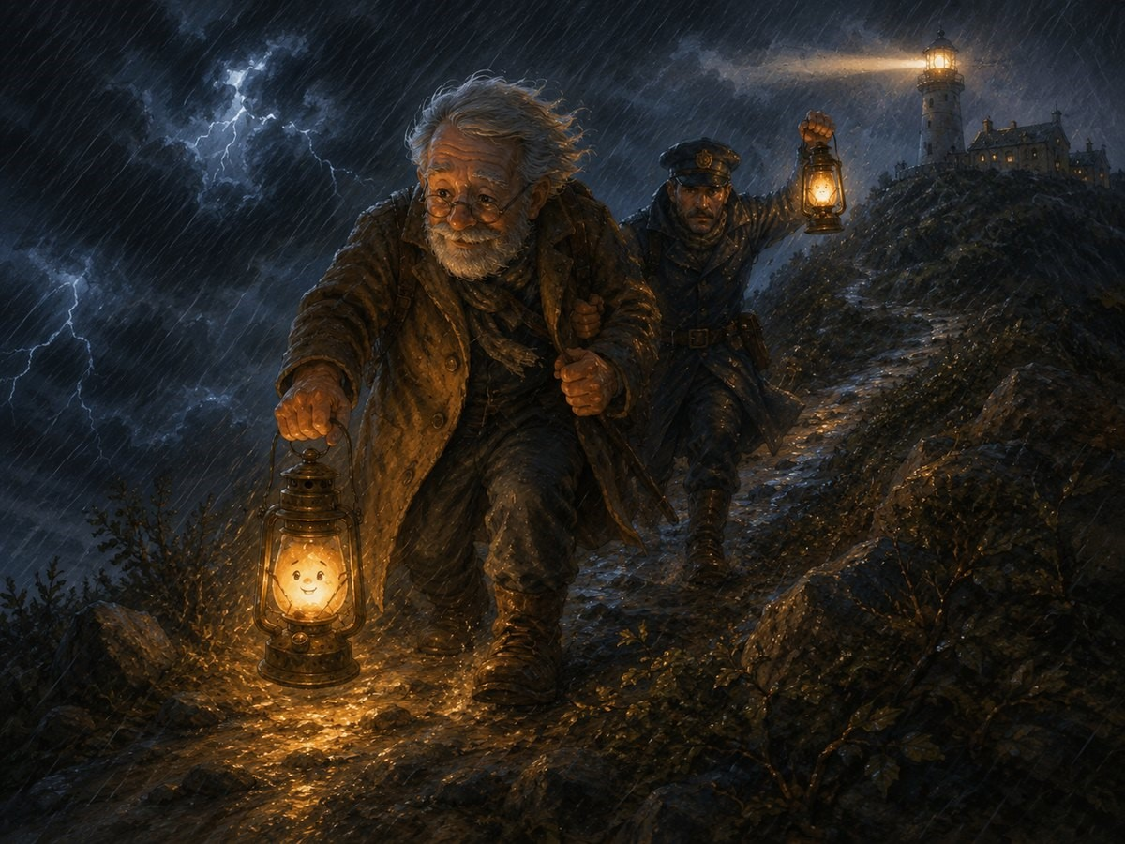
They climbed the spiral stairs inside the lighthouse. Round and round they went, higher and higher, until they reached the top. Grandpa Niko placed Luma by the wide glass window facing the river. Outside, the world was dark and wild.
Luma looked at the river below. She thought of the boats. She thought of the people who might be searching for home. She thought of Mira calling her a little star. So Luma gathered every bit of courage inside her. And she shone.
Her light was not as powerful as the lighthouse beam. It did not sweep across the whole river. It did not reach the farthest hills. But it reached enough. A small golden glow appeared in the lighthouse window.
Down on the river, a boat captain narrowed his eyes. “Look!” he shouted. “A light on the hill!” The sailors turned the boat away from the rocks. Another boat saw the glow too. Then another. One by one, the boats followed the little light safely around the bend.
At the top of the lighthouse, Luma’s flame danced. She was tired. She was wet. She was small. But she did not go out.

Chapter Ten: A Small Light, a Big Difference
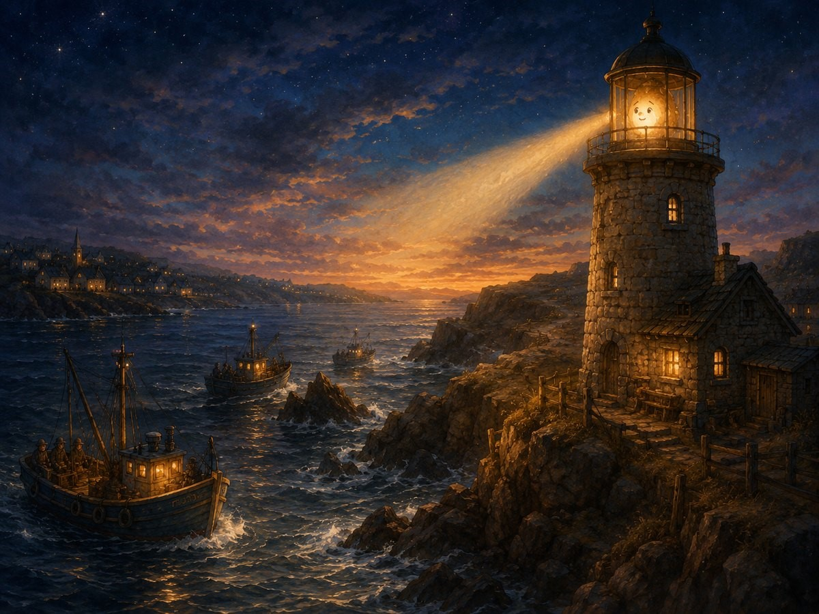
By morning, the storm had passed. The clouds opened, and soft sunlight poured over the village. The river sparkled. The trees dripped with rain. Birds came out of their hiding places and began to sing. Grandpa Niko carried Luma back down the hill.
When they returned to the village, everyone was waiting. Mira ran forward. “You did it!” she cried. The baker bowed. “The little lantern saved the night.” The farmer removed his hat. “Small light, big courage.” The children cheered.
Luma glowed shyly. “I only did what I could,” she said. Grandpa Niko smiled. “That is exactly what bravery is.”
From that day on, Luma no longer wished to be the biggest lantern in the village. She did not need to hang outside the town hall. She did not need to shine over the busy market. She did not need to be the great lighthouse lamp. She was Luma, the little lantern at the end of the narrow lane.
And every evening, when Grandpa Niko lit her flame, she remembered the stormy night when her small light helped many people find their way. Sometimes travellers passed by the repair shop and pointed at the window. “That is the lantern that would not go out,” they would say. Children loved to visit Grandpa Niko’s shop just to see her. Mira often came too, carrying flowers or drawings.
One day, she brought a picture of Luma shining on top of the lighthouse. Under the picture, Mira had written: “Even the smallest light can help someone find the way.” Luma loved those words most of all. And whenever a child felt small, shy, scared, or unsure, Grandpa Niko would point to the little lantern glowing in the window and say:
“Remember Luma. You do not have to be the biggest or the brightest to make a difference. You only have to keep shining.”

Word of Wisdom
You may feel small sometimes, but your kindness, courage, and light can still help someone through the dark.

Questions to Ask Your Child
- Why did Luma sometimes feel small at the beginning of the story?
- Who came to Grandpa Niko’s door and asked for help?
- How did Luma help the villagers during the storm?
- What brave thing did Luma do at the lighthouse?
- What did Luma learn about being small?

